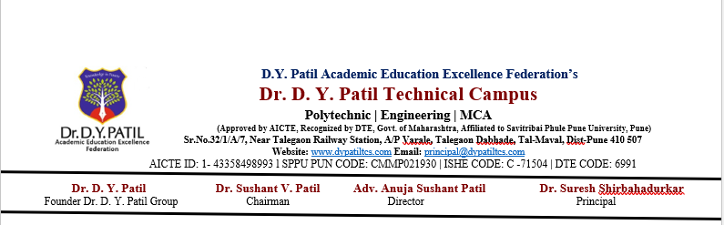
Practical No 6
Problem Statement
Develop a Java program to draw geometric shapes using computer graphics line-drawing algorithms. Implement the DDA (Digital Differential Analyzer) line drawing algorithm to draw two rectangles with dotted and thick line styles, and implement the Bresenham line drawing algorithm to draw a diamond shape with dashed and solid line styles.
import javax.swing.*;
import java.awt.*;

public class LineDrawingAlgorithms extends JPanel {

// DDA Line Drawing Algorithm
private void drawDDA(Graphics2D g, int x1, int y1,
int x2, int y2, String style) {

int dx = x2 - x1;
int dy = y2 - y1;

int steps = Math.max(Math.abs(dx), Math.abs(dy));

float xIncrement = (float) dx / steps;
float yIncrement = (float) dy / steps;

float x = x1;
float y = y1;

for (int i = 0; i <= steps; i++) {

if (style.equals("dotted")) {

// Plot only selected pixels
if (i % 6 == 0) {
g.fillRect(Math.round(x), Math.round(y), 2, 2);
}

} else if (style.equals("thick")) {

// Plot multiple pixels around the main pixel
g.fillRect(Math.round(x), Math.round(y), 5, 5);
}

x += xIncrement;
y += yIncrement;
}
}

// Bresenham Line Drawing Algorithm
private void drawBresenham(Graphics2D g, int x1, int y1,
int x2, int y2, String style) {

int dx = Math.abs(x2 - x1);
int dy = Math.abs(y2 - y1);

int sx = (x1 < x2) ? 1 : -1;
int sy = (y1 < y2) ? 1 : -1;

int err = dx - dy;
int count = 0;

while (true) {

if (style.equals("solid")) {

g.fillRect(x1, y1, 2, 2);

} else if (style.equals("dashed")) {

// Draw 8 pixels and skip 5 pixels
if ((count / 8) % 2 == 0) {
g.fillRect(x1, y1, 2, 2);
}
}

if (x1 == x2 && y1 == y2) {
break;
}

int e2 = 2 * err;

if (e2 > -dy) {
err -= dy;
x1 += sx;
}

if (e2 < dx) {
err += dx;
y1 += sy;
}

count++;
}
}

@Override
protected void paintComponent(Graphics g) {
super.paintComponent(g);

Graphics2D g2 = (Graphics2D) g;

g2.setFont(new Font("Arial", Font.BOLD, 16));

// -------------------------------
// Rectangle 1 - Dotted Line
// -------------------------------

g2.drawString("DDA - Dotted Rectangle", 80, 50);

int x = 80;
int y = 80;
int width = 220;
int height = 120;

drawDDA(g2, x, y, x + width, y, "dotted");
drawDDA(g2, x + width, y, x + width, y + height, "dotted");
drawDDA(g2, x + width, y + height, x, y + height, "dotted");
drawDDA(g2, x, y + height, x, y, "dotted");

// -------------------------------
// Rectangle 2 - Thick Line
// -------------------------------

g2.drawString("DDA - Thick Rectangle", 400, 50);

int x2 = 400;
int y2 = 80;
int width2 = 220;
int height2 = 120;

drawDDA(g2, x2, y2, x2 + width2, y2, "thick");
drawDDA(g2, x2 + width2, y2,
x2 + width2, y2 + height2, "thick");
drawDDA(g2, x2 + width2, y2 + height2,
x2, y2 + height2, "thick");
drawDDA(g2, x2, y2 + height2, x2, y2, "thick");

// -------------------------------
// Diamond - Bresenham
// -------------------------------

g2.drawString("Bresenham - Diamond", 270, 270);

int topX = 400;
int topY = 310;

int rightX = 520;
int rightY = 400;

int bottomX = 400;
int bottomY = 490;

int leftX = 280;
int leftY = 400;

// Top to Right - Dashed
drawBresenham(g2, topX, topY,
rightX, rightY, "dashed");

// Right to Bottom - Solid
drawBresenham(g2, rightX, rightY,
bottomX, bottomY, "solid");

// Bottom to Left - Dashed
drawBresenham(g2, bottomX, bottomY,
leftX, leftY, "dashed");

// Left to Top - Solid
drawBresenham(g2, leftX, leftY,
topX, topY, "solid");
}

public static void main(String[] args) {

JFrame frame = new JFrame(
"DDA and Bresenham Line Drawing Algorithms"
);

LineDrawingAlgorithms panel =
new LineDrawingAlgorithms();

frame.add(panel);

frame.setSize(720, 600);
frame.setDefaultCloseOperation(JFrame.EXIT_ON_CLOSE);
frame.setLocationRelativeTo(null);
frame.setVisible(true);
}
}

